**Working with Parameters in Power BI Desktop**

* Open Power BI Desktop
* Get Data
* SQL Server Database

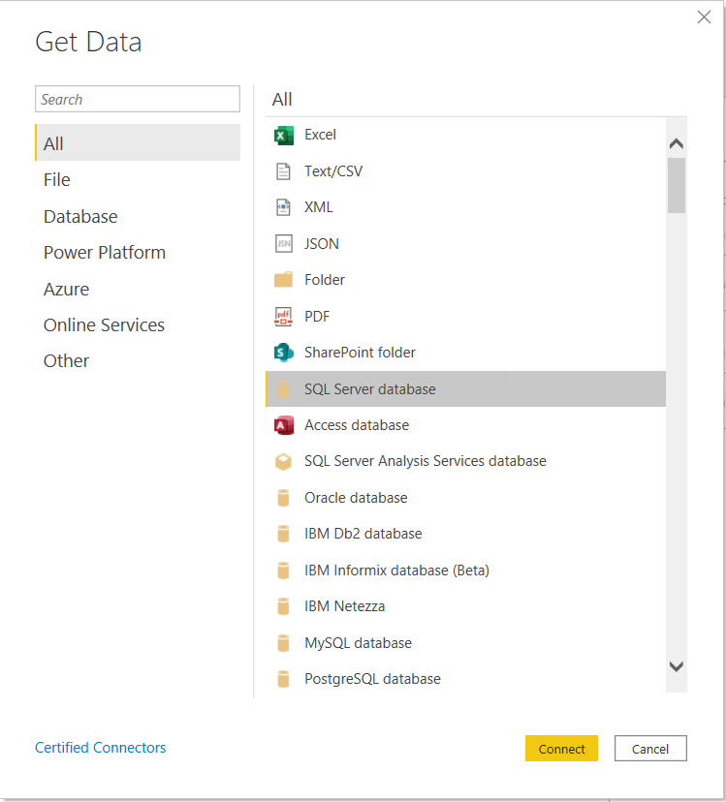

* Server Name -
* Database Name - AdventureWorks
* Direct query
* Advance Options
* SQL Statement – enter below SQL statement

SELECT * FROM Sales.SalesOrderHeader WHERE YEAR(OrderDate) = 2005

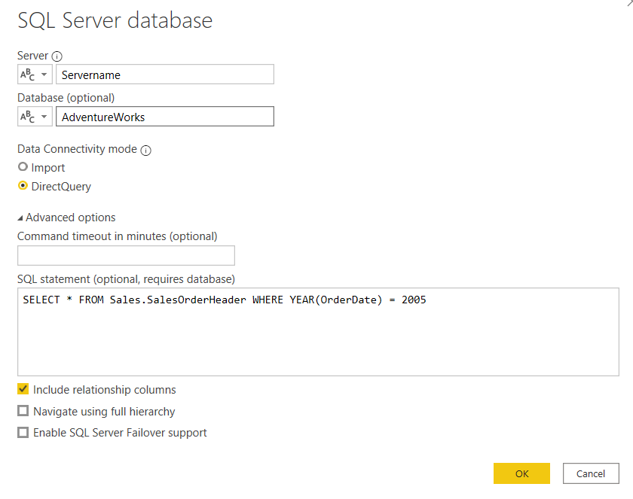

* Click ok
* Then click connect
* Click Transform
* Go to view tab and check Formula Bar and Allow Always

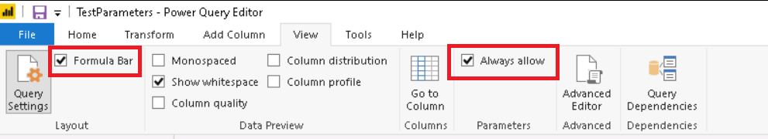

* Click Home tab 🡪 Manage Parameter 🡪 New Parameter
* Add Year

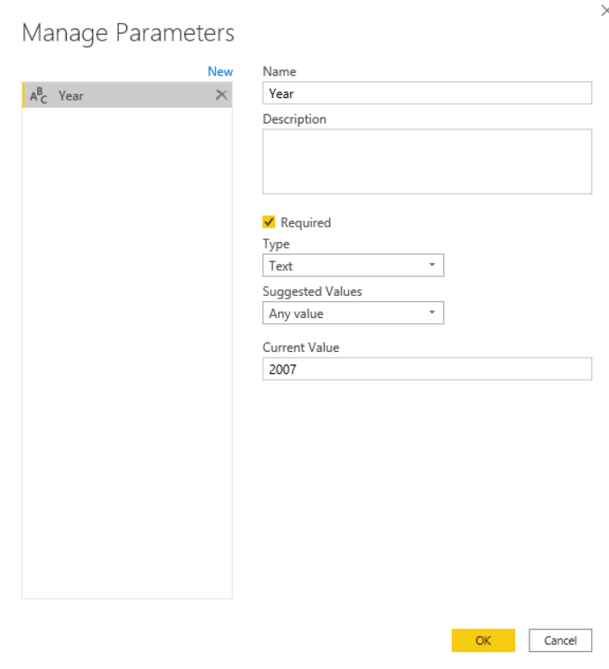

* Add how many parameters need you add it
* Ok and create parameters
* Then Enable load in parameter column

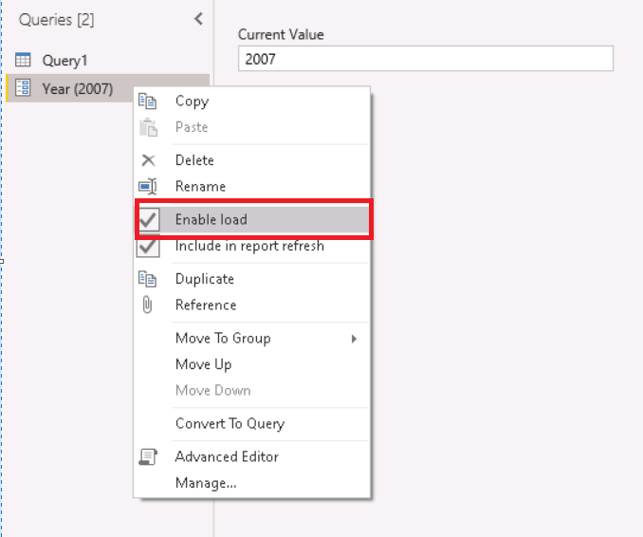

* Then go to formula bar and update the parameter



* Passed year variable
* Click Close and Apply

Test the parameter

Add report/visuals

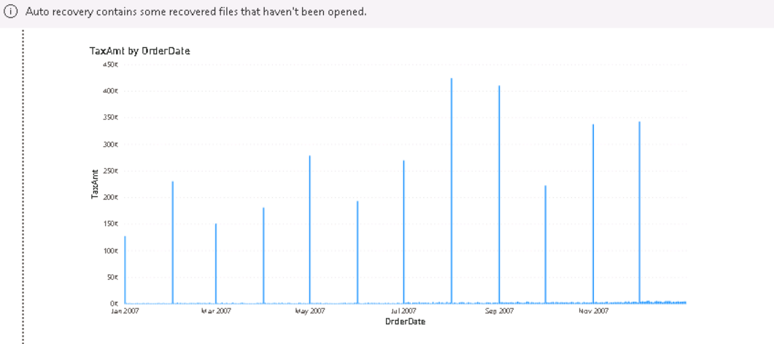

Then Home tab 🡪 Transform data 🡪 Edit Parameters

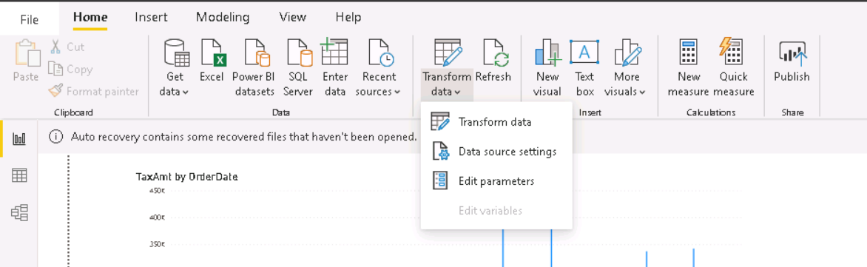

Click Edit Parameters to 2008

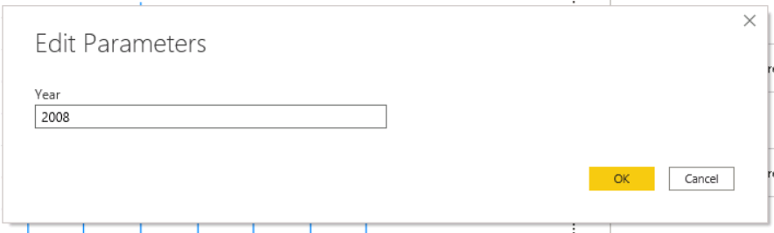

Able to see the updated records

